**IUBAT-International University of Business Agriculture and Technology**

**PROJECT REPORT**

**Submitted By:**

|  |  |  |
| --- | --- | --- |
| **SL** | **Name** | **ID** |
| 01 | Jubaer Ahamed Bhuiyan | 22103112 |
| 02 | Muhaiminul Maliha | 22103149 |
| 03 | Nayla Yousuf | 22103128 |

**Course Name:** Programming in Java

**Course Code:** CSC 383

**Section:** F

**Semester:** Spring 2024

**Program:** BCSE

**Submitted To:**

**Instructor's Name:** Naeem Mia

Dept. of Computer Science and Engineering

**Date of Submission:**

10 May , 2024

**Music Player**

**with  
JavaFX**

**Used Tools**

**Softwares**

1. **IntelliJ IDEA Community Edition 2023.2.4:** IntelliJ IDEA Community Edition 2023.2.4 brings forth enhanced performance and stability, empowering developers with a reliable platform for their projects. With streamlined workflows and intuitive features, it fosters productivity and collaboration within the development community. This version continues to prioritize user feedback, delivering incremental improvements and bug fixes to ensure a seamless coding experience. From its versatile code assistance to its robust debugging capabilities, IntelliJ IDEA Community Edition remains a trusted choice for Java and other JVM-based language development.
2. **Scene Builder:** Scene Builder is written as a JavaFX application, supported on Windows, Mac OS X and Linux. It is the perfect example of a full-fledge JavaFX desktop application. Scene Builder is packaged as a self-contained application, which means it comes bundled with its own private copy of the JRE.

**Libraries:**

1. **javafx.fxml:** For handling FXML files in JavaFX applications.
2. **javafx.scene.control:** Provides UI controls such as labels, list views, and sliders.
3. **javafx.scene.input.MouseEvent:** Used for handling mouse events.
4. **javafx.scene.media:** Provides classes for playing audio and video media.
5. **javafx.stage.DirectoryChooser:** Allows users to select directories in a file chooser dialog.
6. **javafx.animation.KeyFrame:** Represents a single key frame for animations.
7. **javafx.animation.Timeline:** Used for defining animations based on key frames.
8. **javafx.util.Duration:** Represents a duration of time.

**OOP Tools**

1. **Inheritance:** Inheritance in Java is a mechanism in which one object acquires all the properties and behaviors of a parent object. It is an important part of OOPs (Object Oriented programming system).
2. **Encapsulation:** Encapsulation in Java is a process of wrapping code and data together into a single unit, for example, a capsule which is mixed of several medicines.
3. **Polymorphism:** Polymorphism in Java is a concept by which we can perform a single action in different ways. Polymorphism is derived from 2 Greek words: poly and morphs. The word "poly" means many and "morphs" means forms. So polymorphism means many forms.
4. **Abstraction:** Data abstraction is the process of hiding certain details and showing only essential information to the user. Abstraction can be achieved with either abstract classes or interfaces.
5. **Exception Handling:** The Exception Handling in Java is one of the powerful mechanism to handle the runtime errors so that the normal flow of the application can be maintained.

**Features**

1. **User Interface (UI) Components**:
   * Labels for displaying currently chosen music, current time, and total time.
   * Sliders for adjusting volume and seeking through the playing track.
   * List view for displaying available music files in a selected directory.
2. **Media Playback**:
   * Ability to play, pause, stop, and navigate through music tracks.
   * Automatic transition to the next track when the current one ends.
3. **Music Selection**:
   * Directory chooser for selecting a folder containing music files.
   * Support for filtering and displaying only MP3 and WAV files from the selected directory.
   * Dynamically populating the list view with the available music files.
4. **Media Player Control**:
   * Volume control using a slider.
   * Real-time updating of current time and total time labels during playback.
   * Seeking through the track using a slider.
5. **Playback Control**:
   * Play, pause, and stop buttons for controlling playback.
   * Next and previous buttons for navigating between tracks in the playlist.
6. **User Interaction**:
   * Handling mouse events for interacting with UI components.
   * Providing feedback messages when no music files are found in the selected directory.
7. **Data Management**:
   * Managing the current index of the playing track to enable sequential playback.

Overall, the Music Player application allows users to browse and play music files from a selected directory, providing essential playback controls and an interactive user interface for an enjoyable music listening experience.

Top of Form

**Project Screenshots**

Application Starting Interface:

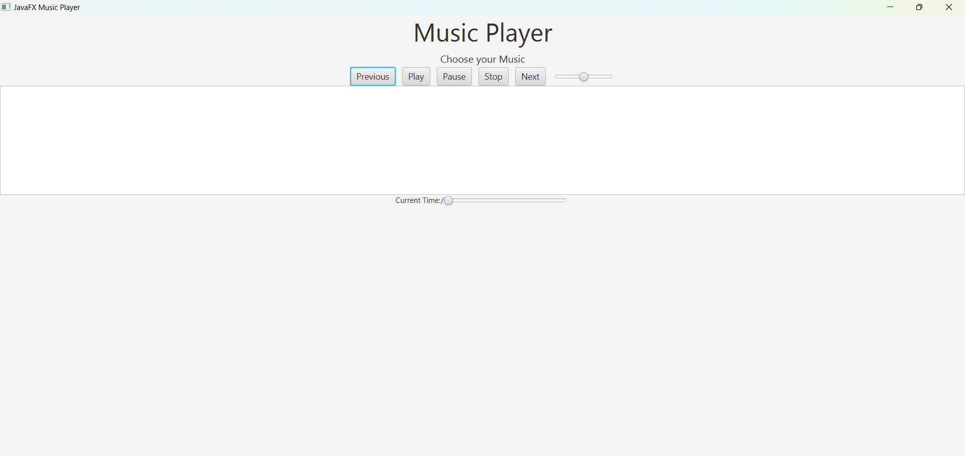

Folder Scanning: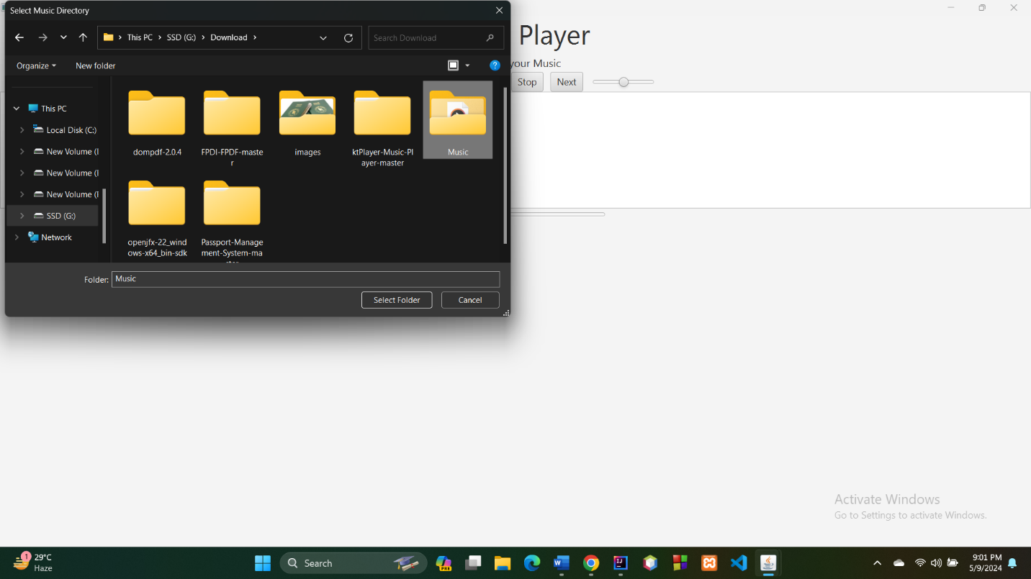

Music Files Imported: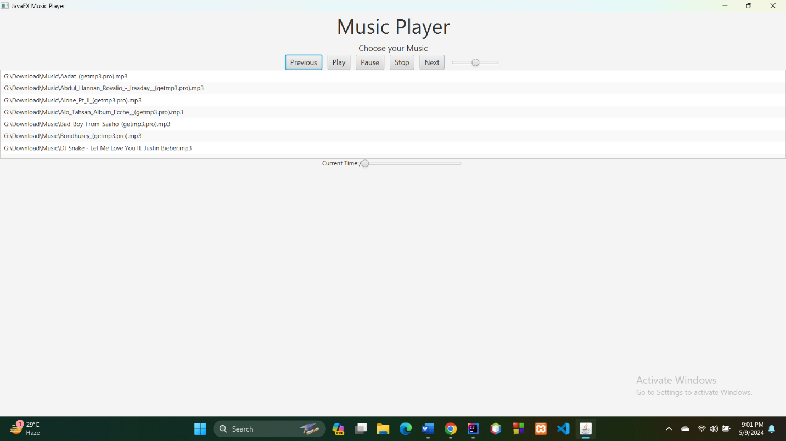

Playing Music: